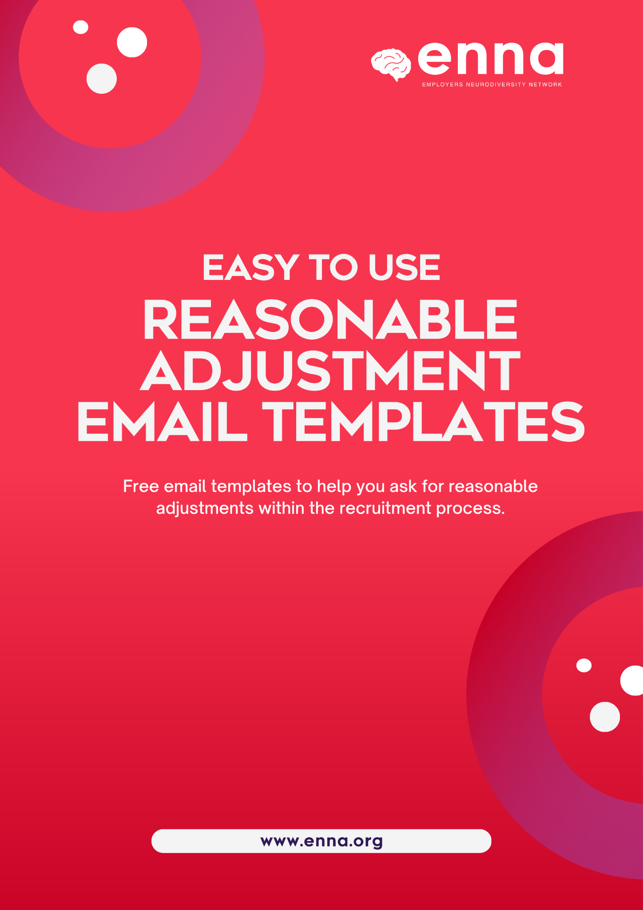

Template 1 - If you know what adjustments you would like
This template is for job-seekers that know what reasonable adjustments they would like to request from a recruiter. This template allows you to input examples to ask for.

—

Subject: Request for Reasonable Adjustments for Upcoming Interview - Neurodivergent Job-Seeker

Dear [Recruiter's Name],

I hope this email finds you well. I am writing to express my enthusiasm for the [Job Title] position at [Company Name] and to discuss the upcoming interview scheduled for [Date and Time]. I would like to take this opportunity to request some reasonable adjustments for the interview process, as I am a neurodivergent individual.

As a neurodivergent job-seeker, I thrive when given an opportunity to showcase my skills and abilities in an environment that accommodates my unique needs. I believe that by making a few adjustments, we can ensure a more inclusive and equitable interview experience, allowing me to present my qualifications effectively. The adjustments I would like to request are as follows:

[please amend the following examples below with examples that could help you, if you aren’t sure, please use our reasonable adjustments request guide to help]

- Alternative Communication Methods: I would greatly appreciate it if we could explore alternative communication methods during the interview, such as written instructions or utilizing visual aids alongside verbal instructions. This approach will help me better process and comprehend the information provided.
- Extended Time Allocation: Given that neurodivergent individuals may require additional time to process and respond to questions, I kindly request an extension of the interview duration. Granting extra time will enable me to showcase my knowledge and skills more accurately, reducing potential stress or anxiety associated with time pressure.
- Clear Interview Structure: It would greatly assist me if the interview could be structured clearly and communicated in advance. Having a breakdown of the interview format, including the number of interviewers, types of questions, and any assessments involved, will help me prepare more effectively.
- Quiet Interview Environment: If possible, I would appreciate a quiet and distraction-free interview setting. Background noise or interruptions can sometimes hinder my ability to focus and perform at my best. Ensuring a calm environment would greatly enhance my ability to engage fully in the interview process.
- Written Feedback: Following the interview, I kindly request written feedback on my performance. This feedback will not only allow me to reflect on my strengths and areas for improvement but also help me better understand how my skills align with the requirements of the role.

I believe that implementing these reasonable adjustments will not only benefit me as a neurodivergent candidate but also contribute to creating a more inclusive and diverse hiring process for all candidates. I understand that providing these adjustments may require some coordination and logistical considerations, and I am more than willing to collaborate with you to ensure a smooth and successful interview experience.

I sincerely appreciate your time and consideration of my requests. If you require any additional information or would like to discuss these adjustments further, please do not hesitate to reach out to me. I am eager to contribute my skills and perspectives to the [Company Name] team, and I look forward to the opportunity to demonstrate my qualifications during the interview.
Thank you once again for your attention to this matter, and I appreciate your support in creating an inclusive environment for all candidates.

Warm regards,

[Your Name]
[Contact Information]

Template 2 - If you do not know what adjustments you would like to request for this interview, but have examples of adjustments other neurodivergent job-seekers have received

This template is for job-seekers that do not know what reasonable adjustments they want to request, but have found some examples either through others or through the internet that have helped other people during the interview process. These job-seekers may want to have a conversation with the recruiter about adjustments.

—

Subject: Request for Collaboration on Reasonable Adjustments for Upcoming Interview - Neurodivergent Job-Seeker

Dear [Recruiter's Name],

I hope this email finds you well. I am writing to express my excitement about the opportunity to interview for the [Job Title] position at [Company Name]. As a neurodivergent individual, I appreciate companies that prioritize inclusivity and value diverse talent.

While I am aware that the interview process is typically standardised, I kindly request your support in exploring possible reasonable adjustments that could optimise my interview experience. As each neurodivergent individual has unique needs, I would appreciate your guidance and expertise in determining which adjustments would be most beneficial for me.
I understand that accommodating these adjustments may require additional coordination and consideration, and I am committed to working collaboratively with you to find mutually agreeable solutions.

Here are some areas where adjustments have proven helpful to neurodivergent individuals in the past:

[please amend the following examples below with examples you have seen, if you aren’t sure, please use our reasonable adjustments request guide to help]

- Communication Methods: Some neurodivergent individuals find it easier to process information through written communication or visual aids. If there are alternative communication methods available, such as providing written instructions or utilizing diagrams, it may enhance my understanding and performance during the interview.
- Interview Duration: Neurodivergent individuals may benefit from extended interview durations, as it allows us to process and respond to questions more thoughtfully. If it is feasible, I kindly request additional time allocation to ensure that I can effectively convey my qualifications and insights.
- Interview Structure: A clear and well-structured interview format can contribute to a positive experience for neurodivergent individuals. Providing an overview of the interview structure in advance, including the types of questions or assessments involved, would allow me to better prepare and showcase my skills during the interview.
- Distraction-Free Environment: A calm and quiet interview setting can help reduce anxiety and facilitate better focus for neurodivergent individuals. If possible, I would appreciate consideration for a distraction-free environment that would enable me to perform at my best during the interview.
- Flexible Breaks: Depending on the individual's needs, taking short breaks during the interview process can be highly beneficial. These breaks allow for self-regulation, stress reduction, and maintaining optimal performance. If breaks can be accommodated within the interview schedule, I would greatly appreciate it.

I understand that implementing these adjustments may depend on the specific circumstances and resources available. I am open to discussing and exploring potential solutions that align with the company's policies and the interview process.

I am grateful for your willingness to consider my request and for fostering an inclusive environment for all candidates. If you require any further information or would like to discuss possible adjustments, please feel free to reach out to me. I am committed to contributing my skills and dedication to the success of [Company Name].

Thank you for your time and attention. I look forward to the opportunity to demonstrate my qualifications during the interview and potentially join the [Company Name] team.

Warm regards,
[Your Name]
[Contact Information]

Template 3 - If you do not know what adjustments you would like to request and aren’t sure of any examples that would help you
This template is for job-seekers that aren’t sure what adjustments they want to request, and they don’t have any examples of adjustments. This can be helpful for people that want to have a conversation with the recruiter to help them.

—

Subject: Request for Collaboration on Reasonable Adjustments for Upcoming Interview - Neurodivergent Job-Seeker

Dear [Recruiter's Name],

I hope this email finds you well. I am writing to discuss the upcoming interview for the [Job Title] position at [Company Name]. As a neurodivergent individual, I believe in fostering an inclusive environment where all candidates have an equal opportunity to showcase their skills and abilities.

I appreciate the effort [Company Name] puts into creating an inclusive hiring process. I am reaching out to you today to discuss the possibility of implementing reasonable adjustments for the upcoming interview. While I understand that adjustments may vary depending on individual needs, I would greatly appreciate your guidance and collaboration to identify suitable adjustments that will help address the challenges I may face during the interview process.

I would like to request a conversation with you to discuss the potential adjustments that could be made to ensure a fair and accessible interview process for all candidates. I am open to exploring various adjustments that align with [Company Name]'s policies and practices. Your expertise and understanding will be invaluable in identifying the most appropriate adjustments for my particular needs.

I truly appreciate your willingness to engage in this dialogue and your commitment to inclusivity. By working together, we can create an environment that supports the full potential of all candidates, including neurodivergent individuals.

Thank you for your time and consideration. I look forward to the opportunity to demonstrate my qualifications during the interview and potentially join the [Company Name] team.

Warm regards,

[Your Name]
[Contact Information]

